Chapter 5, Solution 44.
−+
+
R₄
v_{o}
R₃
v₂
R₂
v₁
R₁
a
b

At node b, 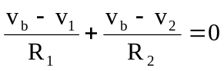 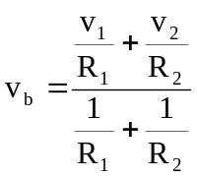 (1)

At node a, 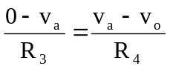 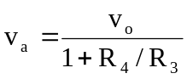 (2)

But v_{a} = v_{b}. We set (1) and (2) equal.

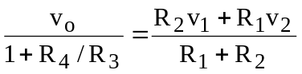

or
v_{o} = 